# Simple Login Page with CSS in React JS

Open our last project (React JS) with VS Code

Then we create login page.

Inside “**src**” folder, create **Login.jsx**  
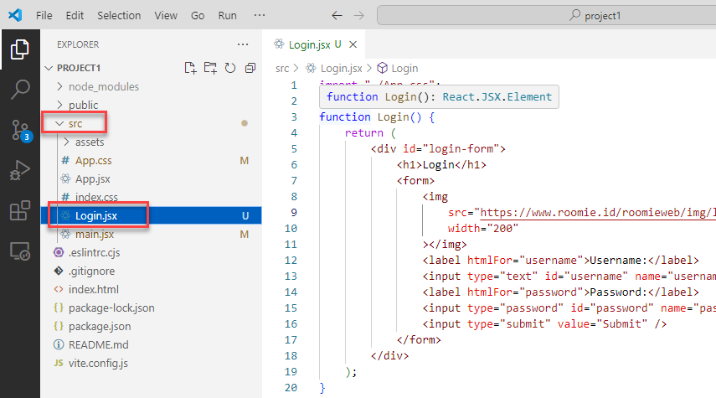

Replace **Login.jsx** with this code:

import "./App.css";

function Login() {

    return (

        <div id="login-form">

            <h1>Login</h1>

            <form>

                <img

                    src="https://www.roomie.id/roomieweb/img/logo/roomie-logo-black.png"

                    width="200"

                ></img>

                <label htmlFor="username">Username:</label>

                <input type="text" id="username" name="username" />

                <label htmlFor="password">Password:</label>

                <input type="password" id="password" name="password" />

                <input type="submit" value="Submit" />

            </form>

        </div>

    );

}

export default Login;

Note: On web-based applications running in a browser, we use CSS to design HTML page.   
For complete documentation for CCS you can find here <https://www.w3schools.com/css/>

Open and replace **App.css** (inside **src** folder) with this code:

#root {

    max-width: 1280px;

    margin: 0 auto;

    padding: 2rem;

    text-align: center;

}

login-form {

    width: 400px;

    max-width: 100%;

    margin: 50px auto;

    background-color: lightblue;

    border-radius: 10px;

    box-shadow: 0 10px 20px rgba(0, 0, 0, 0.1);

    font-family: "Poppins", sans-serif;

}

#login-form h1 {

    text-align: center;

    margin: 0;

    padding: 20px 0;

    font-size: 28px;

    font-weight: bold;

    color: white;

}

#login-form form {

    padding: 20px;

    background-color: white;

    border-radius: 10px;

    font-family: "Poppins", sans-serif;

}

#login-form form label {

    display: block;

    margin-bottom: 8px;

    font-size: 14px;

    color: gray;

    font-family: "Poppins", sans-serif;

}

#login-form form input[type="text"],

#login-form form input[type="password"] {

    width: 100%;

    padding: 12px;

    border: 1px solid lightgray;

    border-radius: 5px;

    font-size: 16px;

    box-sizing: border-box;

    margin-bottom: 20px;

}

#login-form form input[type="submit"] {

    width: 100%;

    padding: 12px;

    background-color: dodgerblue;

    border: none;

    color: white;

    font-size: 16px;

    font-weight: bold;

    border-radius: 5px;

    cursor: pointer;

    box-shadow: 0 4px 6px rgba(0, 0, 0, 0.1);

    transition: background-color 0.3s ease;

}

#login-form form input[type="submit"]:hover {

    background-color: deepskyblue;

    box-shadow: 0 4px 6px rgba(0, 0, 0, 0.3);

}

Open and replace **main.jsx** (inside **src** folder) with this code:

import React from "react";

import ReactDOM from "react-dom/client";

import Login from "./Login.jsx";

import "./index.css";

ReactDOM.createRoot(document.getElementById("root")).render(

    <React.StrictMode>

        <Login />

    </React.StrictMode>

);

Open VS Code terminal and run this command to start project:  
**npm run dev**